Nepal College of Information Technology-2009
Subject: Electromagnetic Fields and Waves

Attempt all the questions

1(a) State Coulomb’s Law. [5]
1(b) Applying Gauss’s law, find the electric field above and below an infinite sheet of charge placed on the z = 0 plane and having a charge density ρ_{S}C/m². [5]
1(c) In a certain region the electric field is given by μC/m²
Find the charge density. [5]
2(a) Define potential. Prove that the electric field is the negative gradient of the potential. [7]
2(b) Define polarization in a material media. Prove that D = εE + P in a medium with permittivity ε = ε₀ε_{r}. [8]
3(a) Two conducting cones(θ = π/10 and θ = π/6) of infinite extent are separated by an infinitesimal gap at r = 0. If V(θ = π/10) = 0 and V(θ = π/6) = 50V, find V and E between the cones. [8]
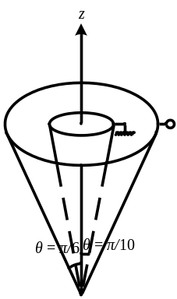
Fig 1
3(b) What do you mean by relaxation time constant? Starting with the continuity equation, show that the relaxation time constant of a material, T_{r} = ε/σ. [7]
4(a) State Ampere’s circuital law. A current carrying filamentary conductor of infinite length is placed along the z-axis. Using Ampere’s circuital law, find the magnetic field at any point P. [8]
4(b) What do you mean by vector magnetic potential? Why is it necessary? [7]
5(a) The magnetic circuit of Fig. 2 has current 10A in the coil of N = 2000 turns. Assume that all branches have the same cross section of 2cm² and that the material of the core is iron with μ_{r} = 1500. Calculate the magnetic flux passing through the air gap. [7]
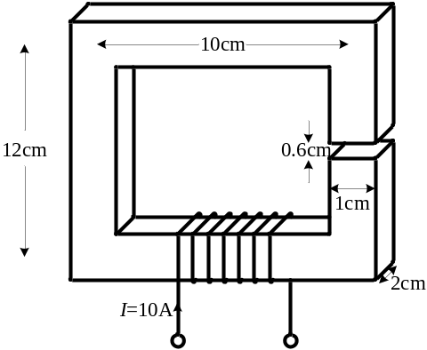
Fig 2
5(b) Write down Maxwell’s equations for static fields and time varying fields both in differential form and integral form. [8]
6(a) Explain wave propagation in free space. What do you mean by uniform plane waves? [8]
6(b) A plane wave propagating through a medium with ε_{r} = 8, μ_{r} = 2 has 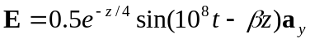V/m. Determine (i) β, (ii) the loss tangent, (iii) wave impedance, (iv) wave velocity and (v) H field. [7]
7 Write short notes on(Any Two) [5×2]
(a) Uniqueness Theorem
(b) Conservative fields
(c) Magnetic and electric boundary conditions
(d) Transmission-lines

